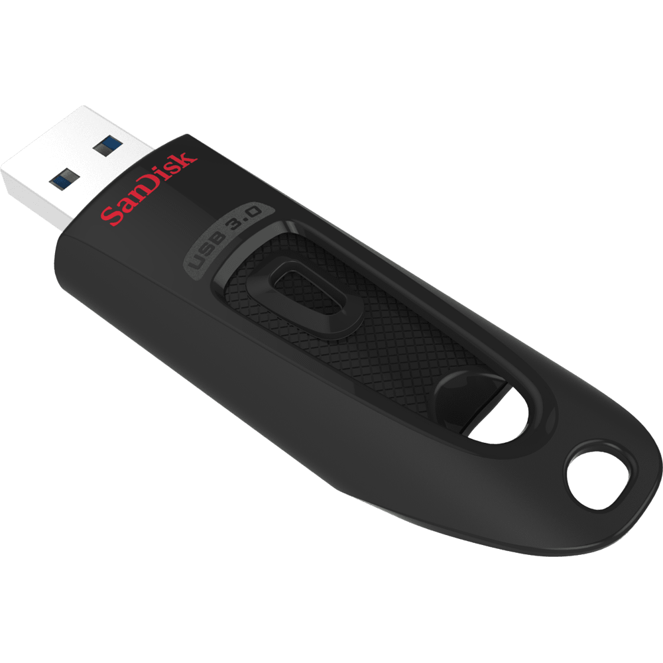

YOUR FILES ARE GOOD TO GO

Music, photos, videos, personal and business files—these days we want access to our stuff wherever we are. With a SanDisk USB flash drive, now you have it.

* **A variety of drives to suit every need and style**
* **Password protection to keep your private files secures**
* **Dependable storage from the industry leader**
* **Capacity: 256 GB**
* **Read Speed: up to 100 MB/s**[**2**](https://www.sandisk.com/home/usb-flash/ultra-usb#footnotes)
* **Generation: USB 3.0**